0611811563 / 0713379023

www.eagleviewguardingservice.co.za
info,eagleguard@gmail.com

COMPANY SERVICES AND PRODUCTS

Dear Sir / Madam
it gives me great pleasure to submit to you our Company compliance, services and products for your perusal. we are confident that your company will benefit extensively from our services and that we can meet and exceed your requirements and deliver a service of superior and acceptable standards.
the primary purpose of a proactive Security framework is to deter crime before it occurs, and not wait , and then react in a traditional reactive enforcement mode. Actions taken up by Management will directly result in an environment that either supports , or does not support , the opportunity the prospective criminal is seeking to act , given that he/she already has the motive , and means. No single safeguard will be build a total barrier against crime; reasonable protective efforts directed towards specific locations , environments , and risk , can in fact be very effective in deterring criminal intent if a security framework is in place and managed correctly. And likewise, a lack of reasonable effort and management will result in a condition that will more likely than not , support future criminal activity and stock loss.
Eagleview Guarding Services ( PTY ) LTD mission is to be the leading Security Company , with exceptional Management Services that is professional and efficient , supplying well trained and motivated security staff performing their duties according to the client's needs , at cost effective price's.
not only does Eagleview Guarding Services ( LTD ) PTY strive to reach a pinnacle of excellence , but to build a strong and standing relationship with our client's. Providing you with a holistic approach. Not only for your security needs but also a wide variety of services.

should you require any further information or assistance please feel free to contact us.
Yours faithfully
Gert Rood Managing Director 061 181 1563 info.eagleguard@gmail.com 011 453 6403 www.eagleviewsecurity.co.za

EAGLEVIEW GUARDUNG SERVICES ( PTY ) LTD
Guarding Services.
Retail Stores Businesses Business Parks
Schools Road Closures Shopping Centre's
Mining Security Home Guarding Street Guarding
Armed Truck Escorts

Special Services.
Special Events Guarding V.I.P Guarding
Body Guarding Bank Escorts
Business Escorts Home Escorts
Armed Escorts to and from O.R Tambo Airport

EAGLEVIEW GUARDING SERVICES ( PTY ) LTD
Technical Services.
Systems , Alarm Systems , Electric Fencing , Gate Motors , Gate Motor Anti F Brackets , Intercoms and more we stock supply and install all your security needs.

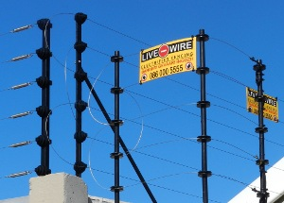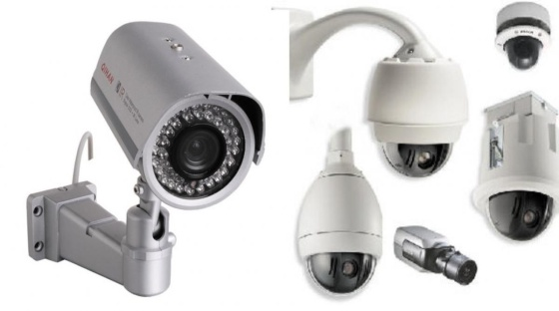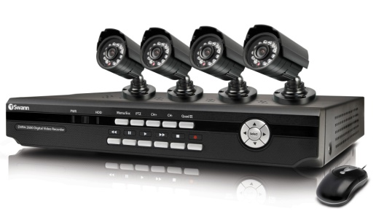

SUPPLIER OF ALL YOUR SECURITY NEEDS.
011 453 6403
012 753 2289
Technical Support
084 567 2288 Mon to Friday
8 to 5pm
www.EAGLEVIEWSECURITY.com

COMPANY AND ORGANISTION.
The company was established on the basis of excellent service delivery to their client's. The co-founders , with extensive experience within the Security Industry , identified a lack of service Delivery in the Security Industry and due to their passion for this Industry the company has grown quadrupling client's , With this said Eagleview Guarding Services ( PTY ) LTD has proven that we can compete with any Security provider within the Market Place and exceed all expectations by delivering excellent service.
EAGLEVIEW GUARDING SERVICES VISSION
Striving for security excellence by enhancing relationships with staff and clients to ensure an equal feeling of a lasting partnership.

EAGLEVIEW GUARDING SERVICES MISSION
Through service , determination and management we will create lasting client satisfaction this creating long term relationships with our clients and providing them with a guaranteed sense of professional service.

EAGLEVIEW GUARDING SERVICES OPERATIONAL STRATEGY
We are of the opinion that the management of the contract is the absolute key to the success of a loss control program.
A Service Level Agreement which translates operationally into "Site Procedure Training Manual" will be agreed to and signed by both parties.
Our operation will therefore be based on a set of client specific instructions and procedures complied and agreed upon by our Clients and Eagleview Guarding Services. The Site Procedure Manual is however a dynamic document and should be reviewed on a monthly basis to adjust the Security operation to suit the prevailing circumstances. These policies and procedures will be documented and implemented by our Site Manager in conjunction with our clients and Area Managers.
The manpower compliment that will be deployed will be required to meet P.S.I.R.A standards , Additional Site specific training will be provided by our Area Manager from Eagleview Guarding Services. All personnel will be suitably trained on the Site Procedure Manual and tested by Eagleview Guarding Services Management before induction on the site may proceed

Site visits by top managements.

EAGLEVIEW GUARDING SERVICES
Strengths
PSIRA Registered and Experienced Security Officers will be employed.
Eagle Guarding Services believe in maintaining good Security officers to manager ratio.
Management will visit the site weekly.
Full Management reports on Security officers and occurrences will be compiled on a monthly basis.
Our focus is to deliver an excellent service to our clients by ensuring individual focus on both clients and staff.
All Managers and Directors will be on 24 hours standby.

Site take on procedures
Assessment and discussion of client requirements.
Screening and selection of security officers.
Site specific training of security officers.
Circulation of job descriptions , policies and procedures for every security officer.
Site training for relevant managers.
occurrence book ( OB ) held on site.
Continual on site training.

MANAGEMENT.
GERT ROOD - MANGING DIRECTOR
Due to his invaluable knowledge of the industry and excellent customer service he has become an integral part to the company's success. Gert currently holds the position of Managing Director. His dedication and willingness to service is evident in our customer satisfaction measured on a regular basis. Gert is overall accountable for the national operational services within the company fulfilling his responsibility trough a well structured highly skilled framework , consisting of operational , regional and area managers.

GERT ROOD TRAINING HISTORY.
Gert is responsible for the development , implementation and management of some tailor made security management programmes and risk control services within a leading retail , commercial , and industrial client base.Gert enlisted with the South African Defence Force for his National Service in 1990. Due to his determination as a soldier defending his country he was elected to attend a non-commisioned officers training course.Leadership and management abilities were identified here in Gert. After his leadership course he was transferred to 1 Maintenance Unit Kimberley where he held rank of sgt. Subsequent to his national service coming to an end , Gert pursued a career within the Security industry.This was largely due to the strong discipline ethics and morals instilled in him during his national service. The Fidelity Cash in Transit Group Cleveland Johannesburg employed him , he attended advanced training in various aspects of the industry which skilled him to excel.

these courses included:
- Tactical Firearm Training
- Armed Escorts of Human and valuable assets
- Crowd Control , Behaviour and Faction Studies
- Risk Management
- Corporate Governance
- Labour relations
- Human Resources
- Risk Assesments

Gert worked through the ranks and was further elected to complete all his security coures over the years. A national security company employed him in the capacity of Area Manager. it wasn,t long before his past experience paid off and he was promoted to operations Manager. Gert held the position of Operations Manager , which meant that due to his strong client liaison skills he knew exactly what service was expected.

Gert dedecated is life to make sure clients property and assets are protected at all means.

TRAINING PROGRAMMES.

Every 6 months Security Officers are subjected to a site specific test based on client specific procedures. The pass mark for this test is 85% , should the security officer fail the security officer will be given three to five days to study and then re-write the test. should the security officer fail again , Eagleview Guarding Services thereafter has no option but to remove the security officer from the site and follow retrenchment procedures.

Apart from the site Specific test and training the following forms part of continuous training of Security Officers either on site or off site at our Head Office or Training institutions:
- Incident Reports
- Access Control
- Searching Standards and Procedures
- Code of conduct
Disciplinary code and procedures
- Action in case of an a emergency
- Radio Communication according to Company Standards
- FSK Electronic Guard Monitoring Training
- Company Rank Structure and Chain of Command
- Rules and Regulations for security officers
- Absenteeism
- Company Uniform
- Company Structure
- Grievance Procedures
- Housekeeping of Company and Client property
- Hand over and Take over off shifts
- Recording in the ( OB ) Occurrence Book
- Basic Reporting Writing of Statements
- Daily Parades
- Continuous Site Orientation training
- How to check Alarm Activations
- Electric Fence checks
- Management Instructions
- Client Instructions
- Confidentiality Agreement

SECURITY GUARD MONITORING SYSTEM
Eagleview Guarding Services ( PTY ) LTD make use of the following Computer Management Systems.
FSK Guard Monitoring System.

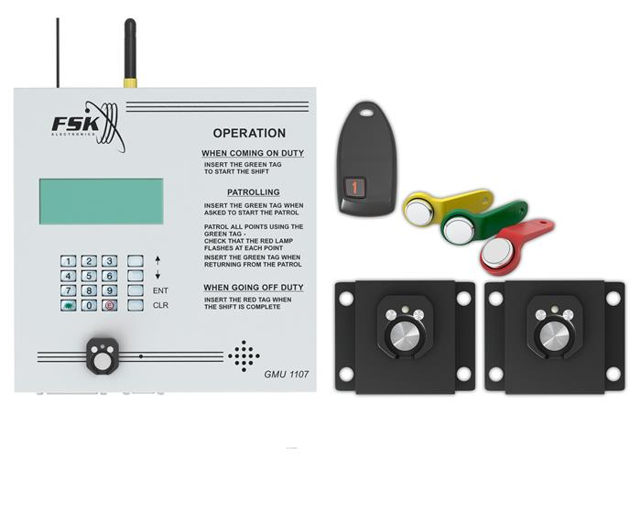

NON-LETHAL WEAPONS.
This non-lethal weapons will only be on site on request of client and signed on all documents and contracts.

This non-lethal weapons stops any criminal in its tracks and will keep him down for 30 minutes.

SECURITY OFFICERS SITE SUPLIES.
All Eagleview Guarding Services security officers will be supplied with full uniform note book and pens. Occurrence Books and Access Control books will be supplied by Eagleview Guarding Services.

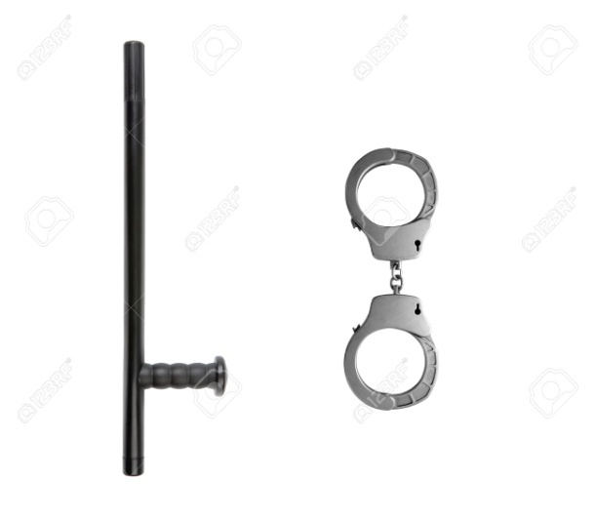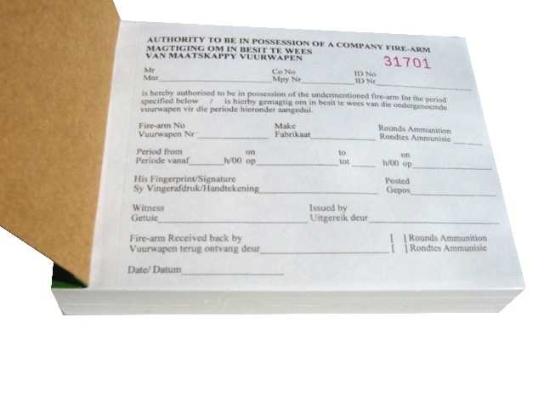

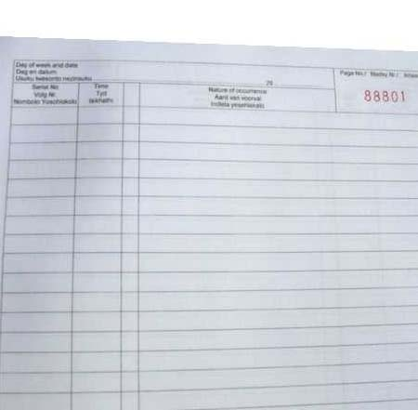

2way radios on site.
All 2way radio's will be contracted out to client for a monthly fee

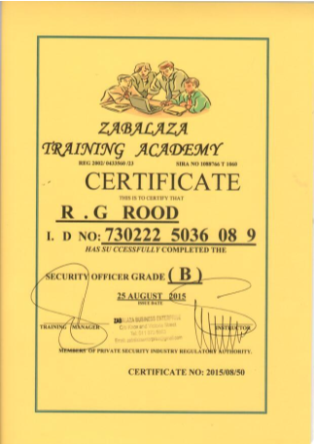

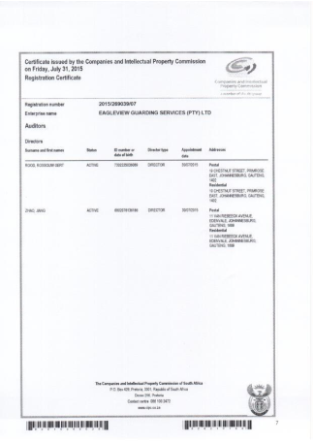

services to our clients.

Risk advisory / Risk assessments
Due to our extensive experience with the retail industry , Eagleview Guarding Services has the expertise to assist with the Risk advisory and Risk assessments. We would gladly come out and do a full Risk assessment Level 1 for you with report and photo's.

Investigations
As a result of our past success this type of service has now become imperative to assist our clients in solving security related risks and shortcomings. We offer this service at a affordable cost.

EAGLEVIEW GUARDING SERVICES ( LTD ) PTY
CONTRACTS
All contracts are based on a two ( 1 ) year contract should a client which to terminate the contact it is therefore the clients responsibility to terminate the contract in writing not less than 30 days before termination , client shall be held responsible for any fees in this contract up to date of receiving written cancellation has been received by Eagleview Guarding Services.

CHARGES / PAYMENTS
INVOICING
The client agrees to pay monthly charges as indicated on the contract agreement , from the commencement and uninterruptedly until date of termination. Fees may be revised on a yearly bases.
All payments shall be made without deduction of any kind and free of all exchange , band/or other changes.
Payments must be made on or before the 28th day of each month

Eagleview Guarding Services serves the right to ad 15% interest for all late payments to them.
Increase is due annually on 1st September as per P.S.I.R.A

Guarding prices
Grade D Day Shift Guard R8883,00
Grade D Night Shift Guard R9301,00
SFK Guard Monitoring System R525,00
Base Radio to Control Room R500,00
Hand Radio on site R180,00
Cell Phone R285,00

All this prices is excluding Vat Per Month.
Annual increase 1 Sept

Armed Escorts.
paid per trip per km
R9.90 Per Kilometer

